Test Case: tc001_SPX_Dev5_Crear_Solicitud_Articulo_Almacen
Step 1 - Enter username and password and click to button Enter : Credentials Entered
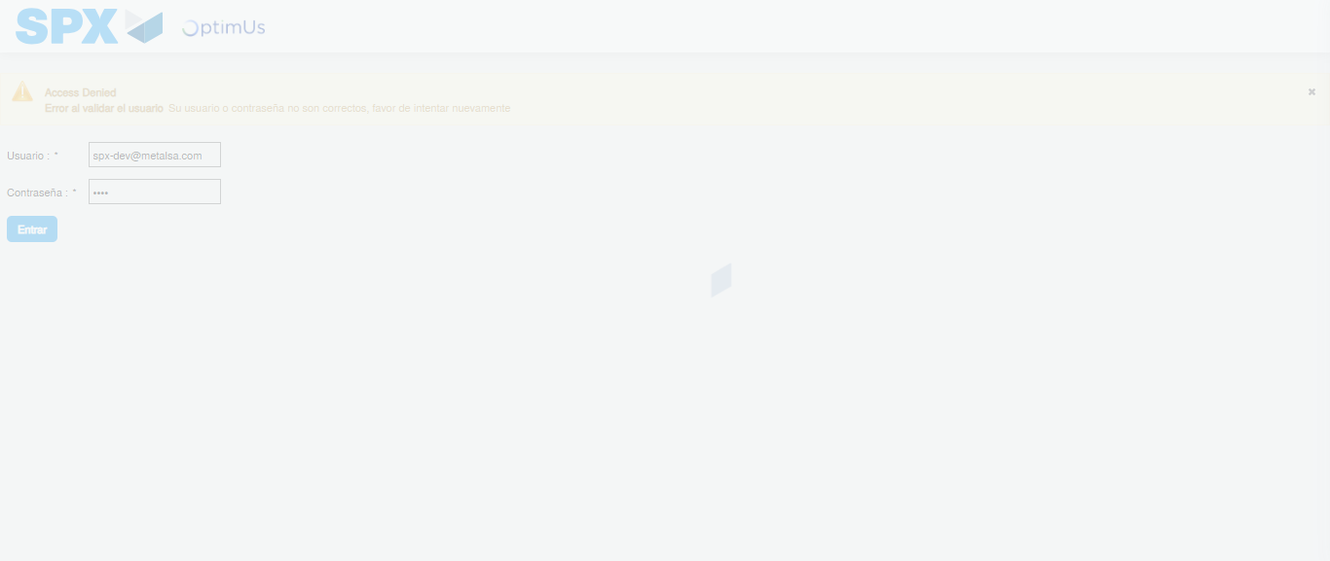Image file-name: QC_Testing-tc001_SPX_Dev5_Crear_Solicitud_Articulo_Almacen-1788279847225

Step 2 - Select to UEN and Access to Request for a New Inventory Item : UEN Correctly selected and Correct access
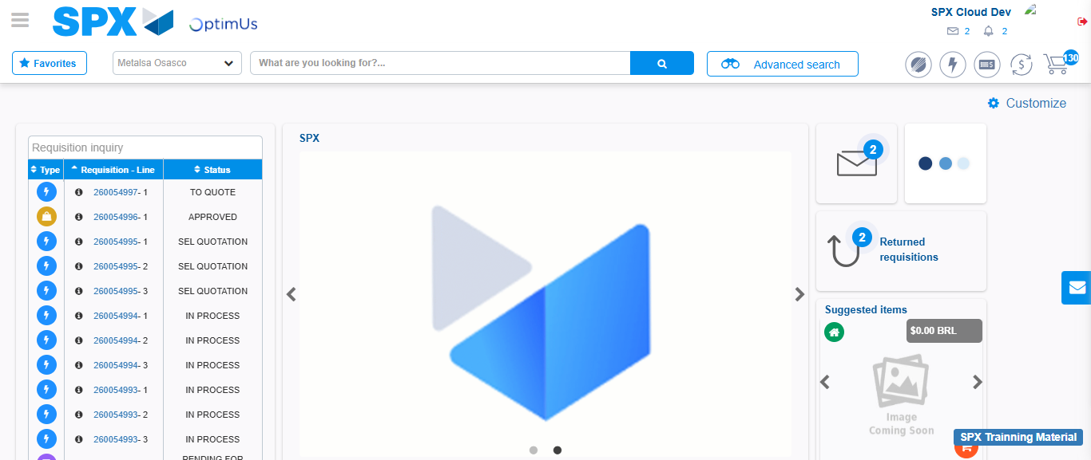Image file-name: QC_Testing-tc001_SPX_Dev5_Crear_Solicitud_Articulo_Almacen-1788279873404

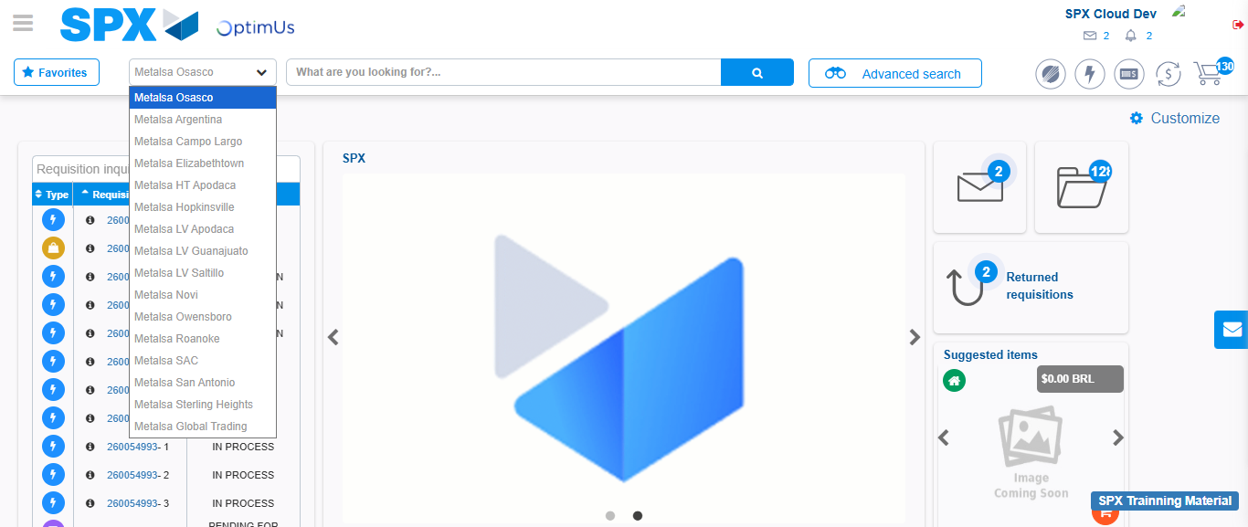Image file-name: QC_Testing-tc001_SPX_Dev5_Crear_Solicitud_Articulo_Almacen-1788279874395

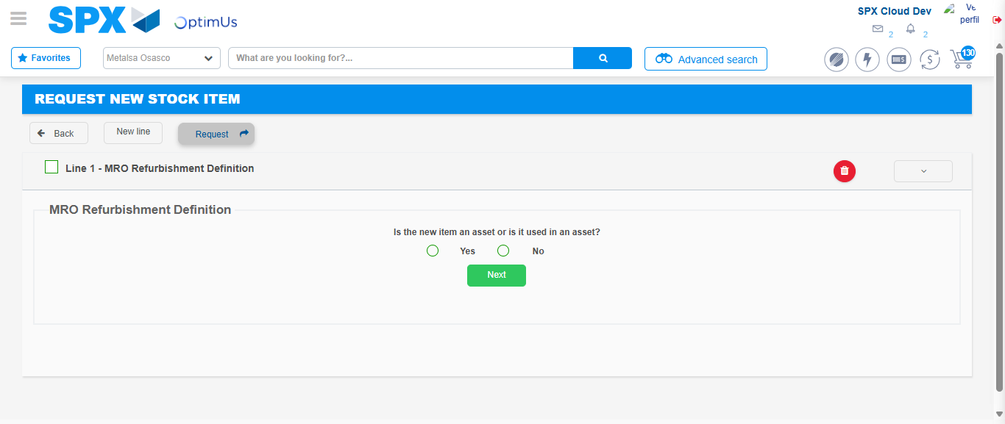Image file-name: QC_Testing-tc001_SPX_Dev5_Crear_Solicitud_Articulo_Almacen-1788279894563

Step 3 - Select options first section : Options seleted correctly
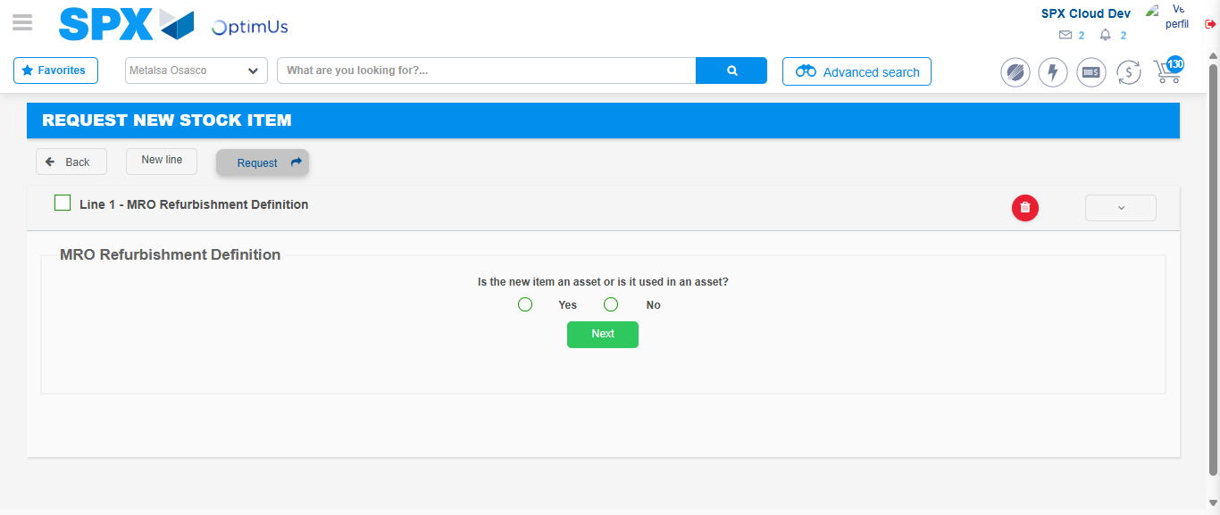Image file-name: QC_Testing-tc001_SPX_Dev5_Crear_Solicitud_Articulo_Almacen-1788279894976

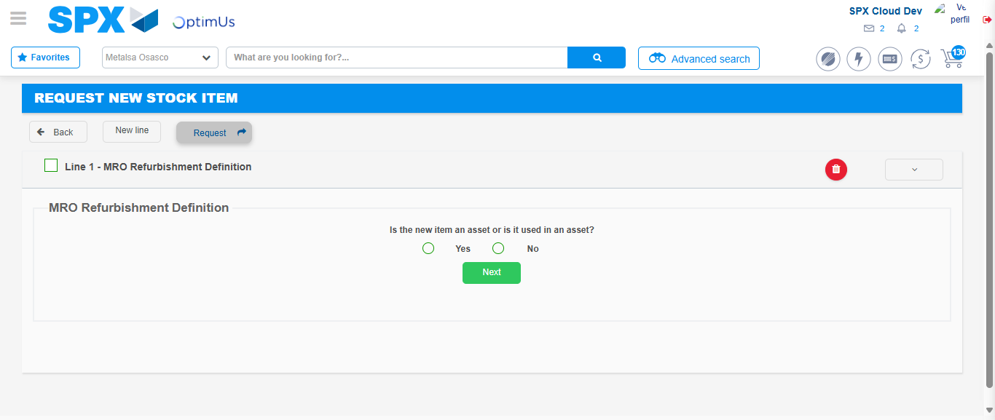Image file-name: QC_Testing-tc001_SPX_Dev5_Crear_Solicitud_Articulo_Almacen-1788279895251

Step 4 - Select options at Screen: Options seleted correctly
Image file-name: QC_Testing-tc001_SPX_Dev5_Crear_Solicitud_Articulo_Almacen-1788279894976

Image file-name: QC_Testing-tc001_SPX_Dev5_Crear_Solicitud_Articulo_Almacen-1788279895251

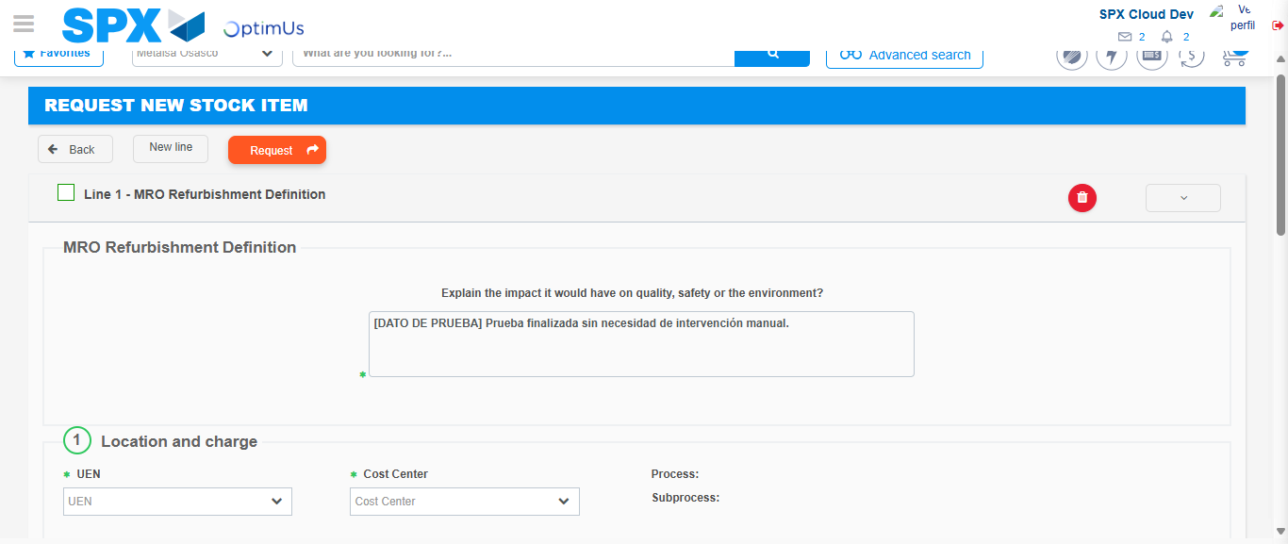Image file-name: QC_Testing-tc001_SPX_Dev5_Crear_Solicitud_Articulo_Almacen-1788279910365

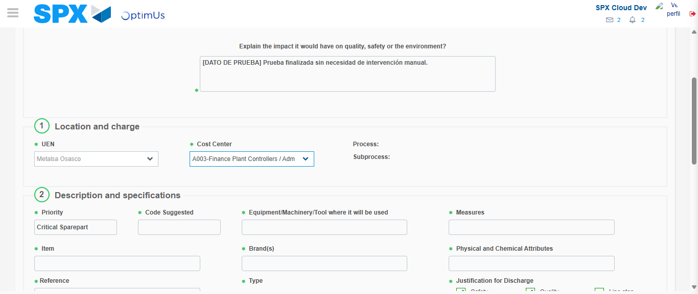Image file-name: QC_Testing-tc001_SPX_Dev5_Crear_Solicitud_Articulo_Almacen-1788279913708

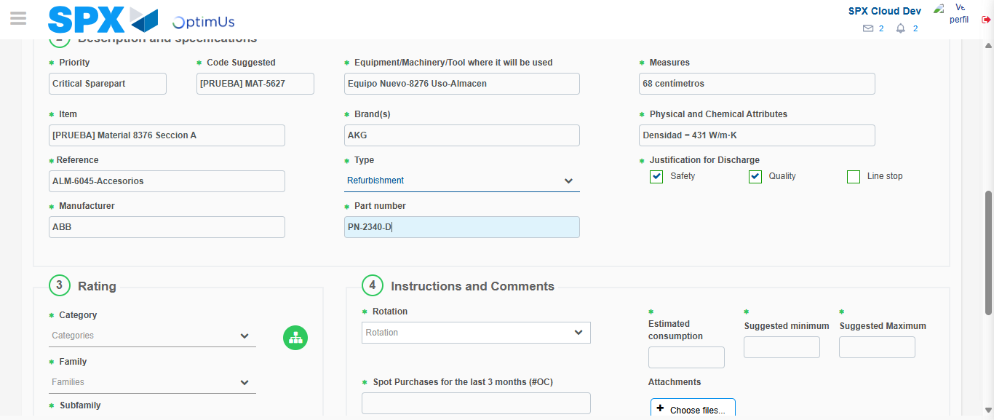Image file-name: QC_Testing-tc001_SPX_Dev5_Crear_Solicitud_Articulo_Almacen-1788279916330

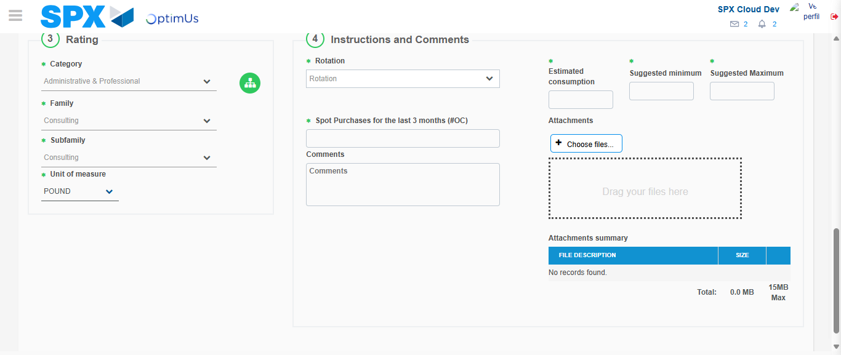Image file-name: QC_Testing-tc001_SPX_Dev5_Crear_Solicitud_Articulo_Almacen-1788279922171

Step 5 - Request New Item : Request Accepted
Image file-name: QC_Testing-tc001_SPX_Dev5_Crear_Solicitud_Articulo_Almacen-1788279873404

Image file-name: QC_Testing-tc001_SPX_Dev5_Crear_Solicitud_Articulo_Almacen-1788279874395

Image file-name: QC_Testing-tc001_SPX_Dev5_Crear_Solicitud_Articulo_Almacen-1788279894563

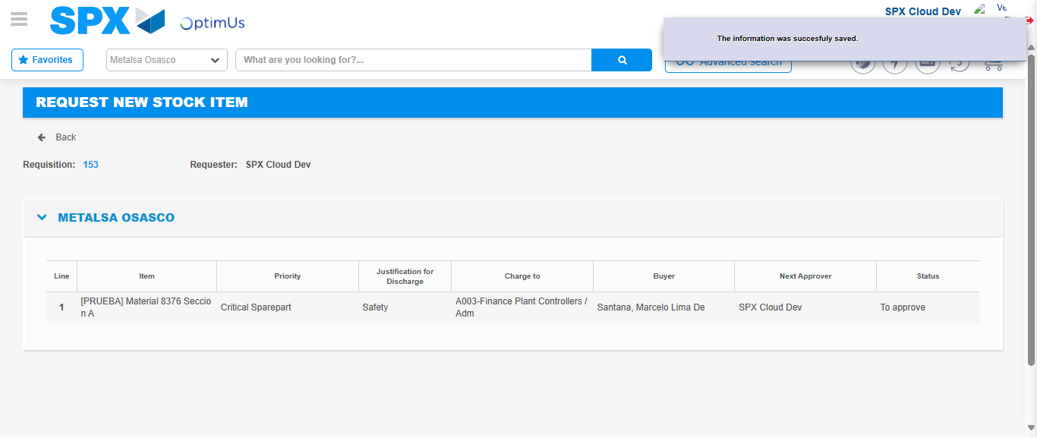Image file-name: QC_Testing-tc001_SPX_Dev5_Crear_Solicitud_Articulo_Almacen-1788279930468

Image file-name: QC_Testing-tc001_SPX_Dev5_Crear_Solicitud_Articulo_Almacen-1788279930704

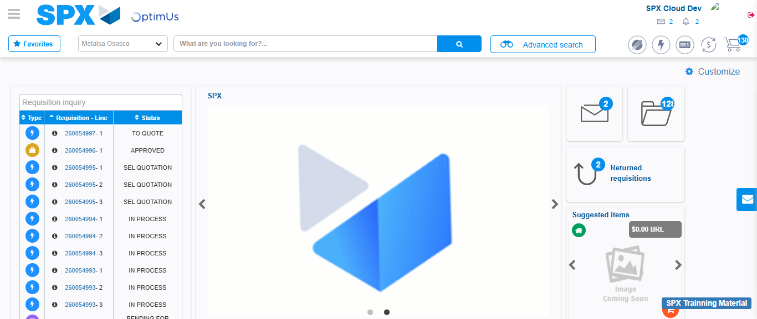Image file-name: QC_Testing-tc001_SPX_Dev5_Crear_Solicitud_Articulo_Almacen-1788279952416

Step 7 - Return to Main Page SPX : Return to Main Page SPX
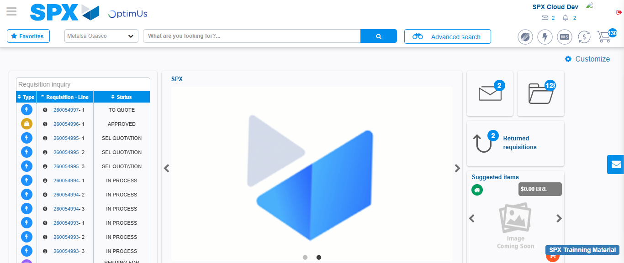Image file-name: QC_Testing-tc001_SPX_Dev5_Crear_Solicitud_Articulo_Almacen-1788279952798

